AWS RDS lab 4

Step by step guide to create a serverless aurora database.

Step 1:Login to the aws account and navigate to the RDS console.

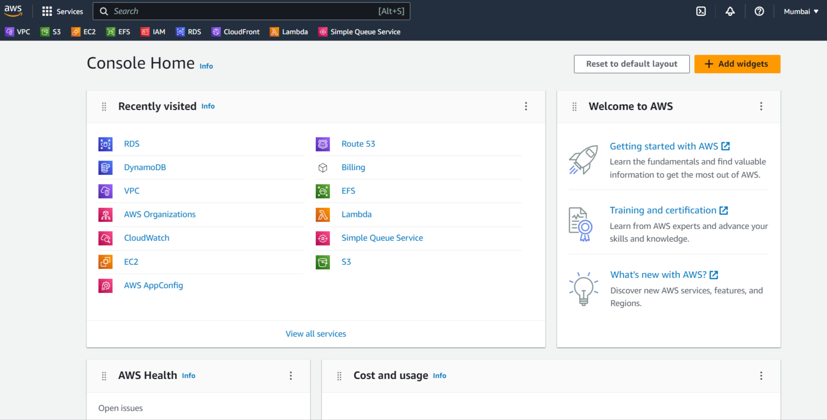

Step 2: On the RDS console,click on “Create Database” to create a serverless database.

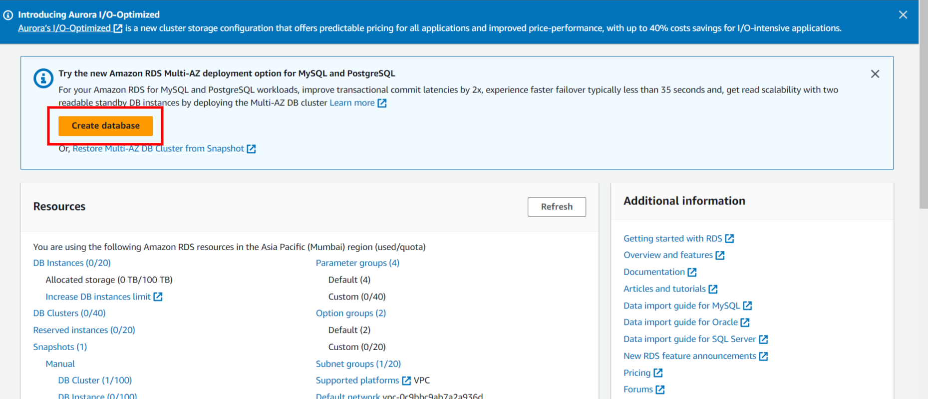

Step 3:Select the database creation method and “Aurora” engine type for your database.

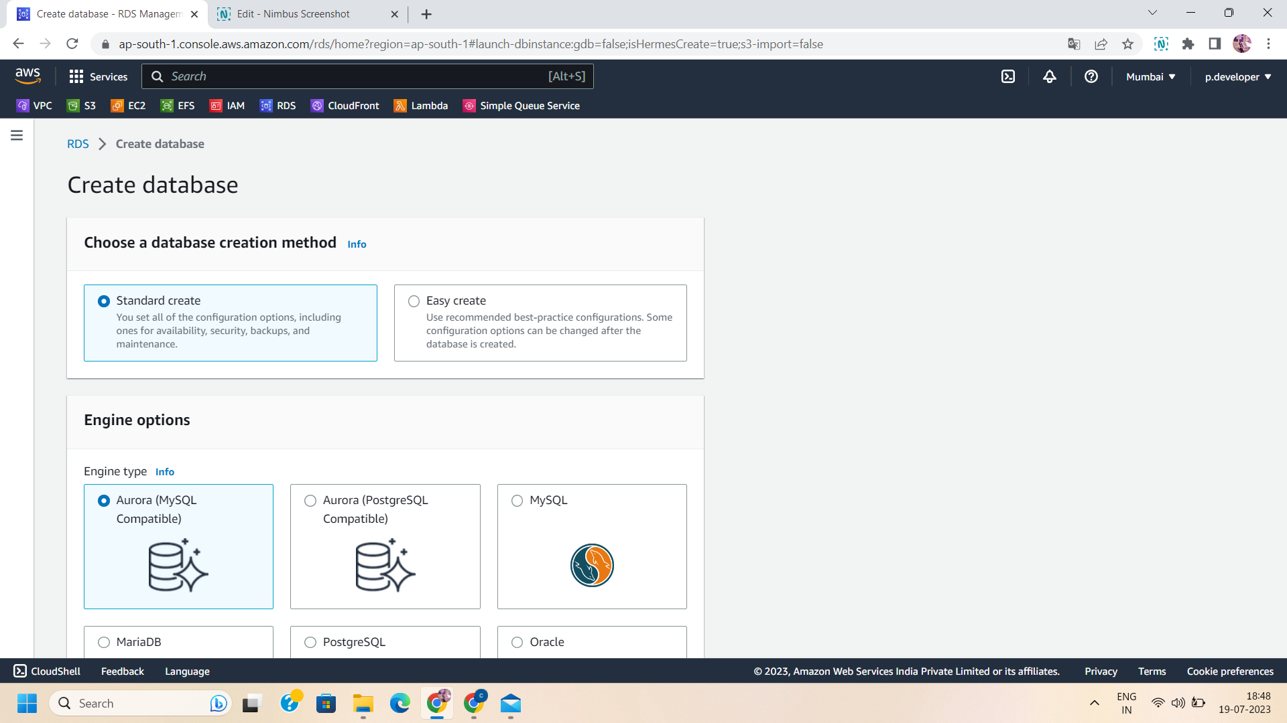

Step 4: enable the serverless v2 and select the desired version of the aurora MySQL database.

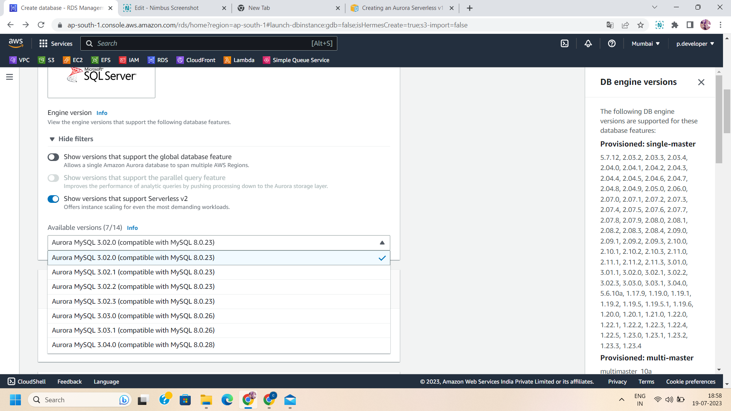

Step 5:Select the template “Dev/Test” and give a unique name to your Database cluster.

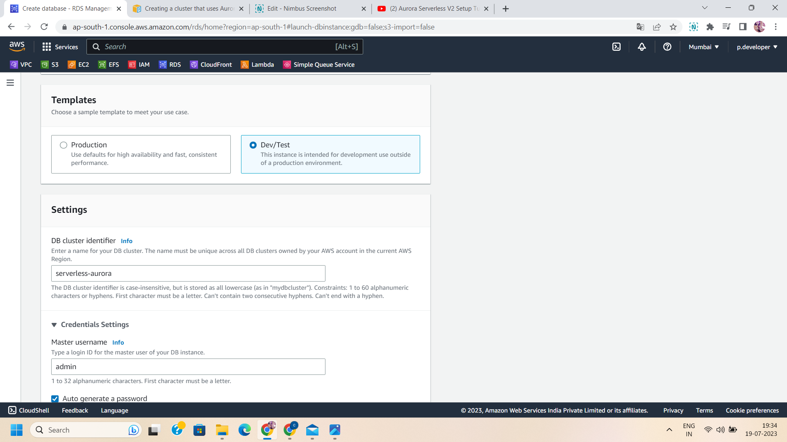

Step 6:configure credentials:

Manage the username and strong password for the database.

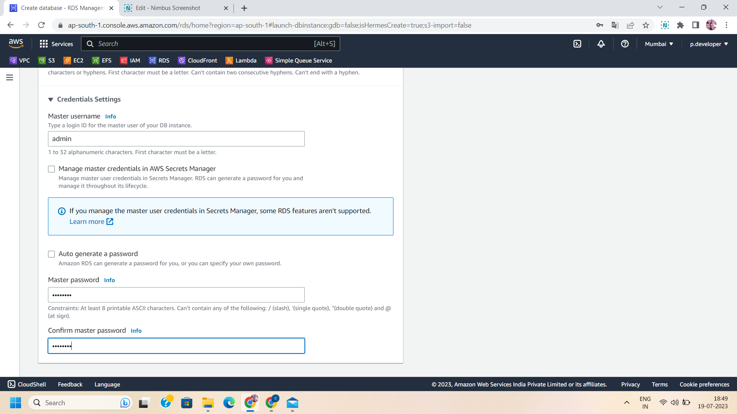

Step 7:Manage the cluster storage configurations-aurora standard or aurora I/O optimized.

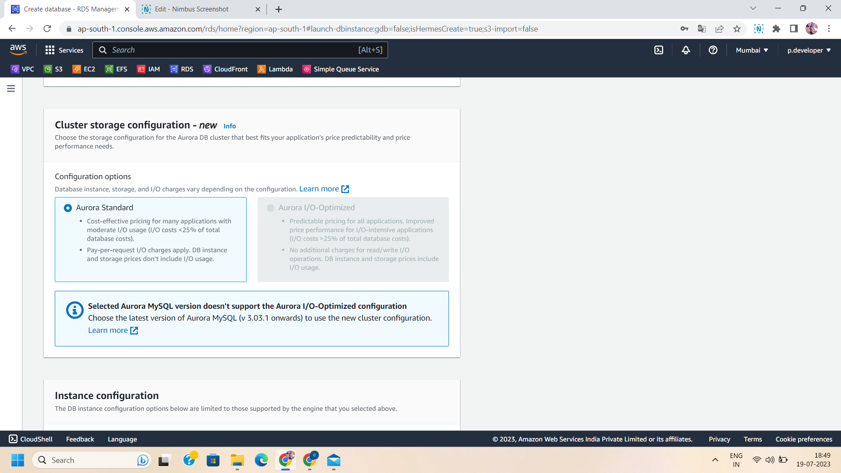

Step 8: Manage the instance configuration:

Select the serverless v2 instance class and scale up or scale down the capacity range .

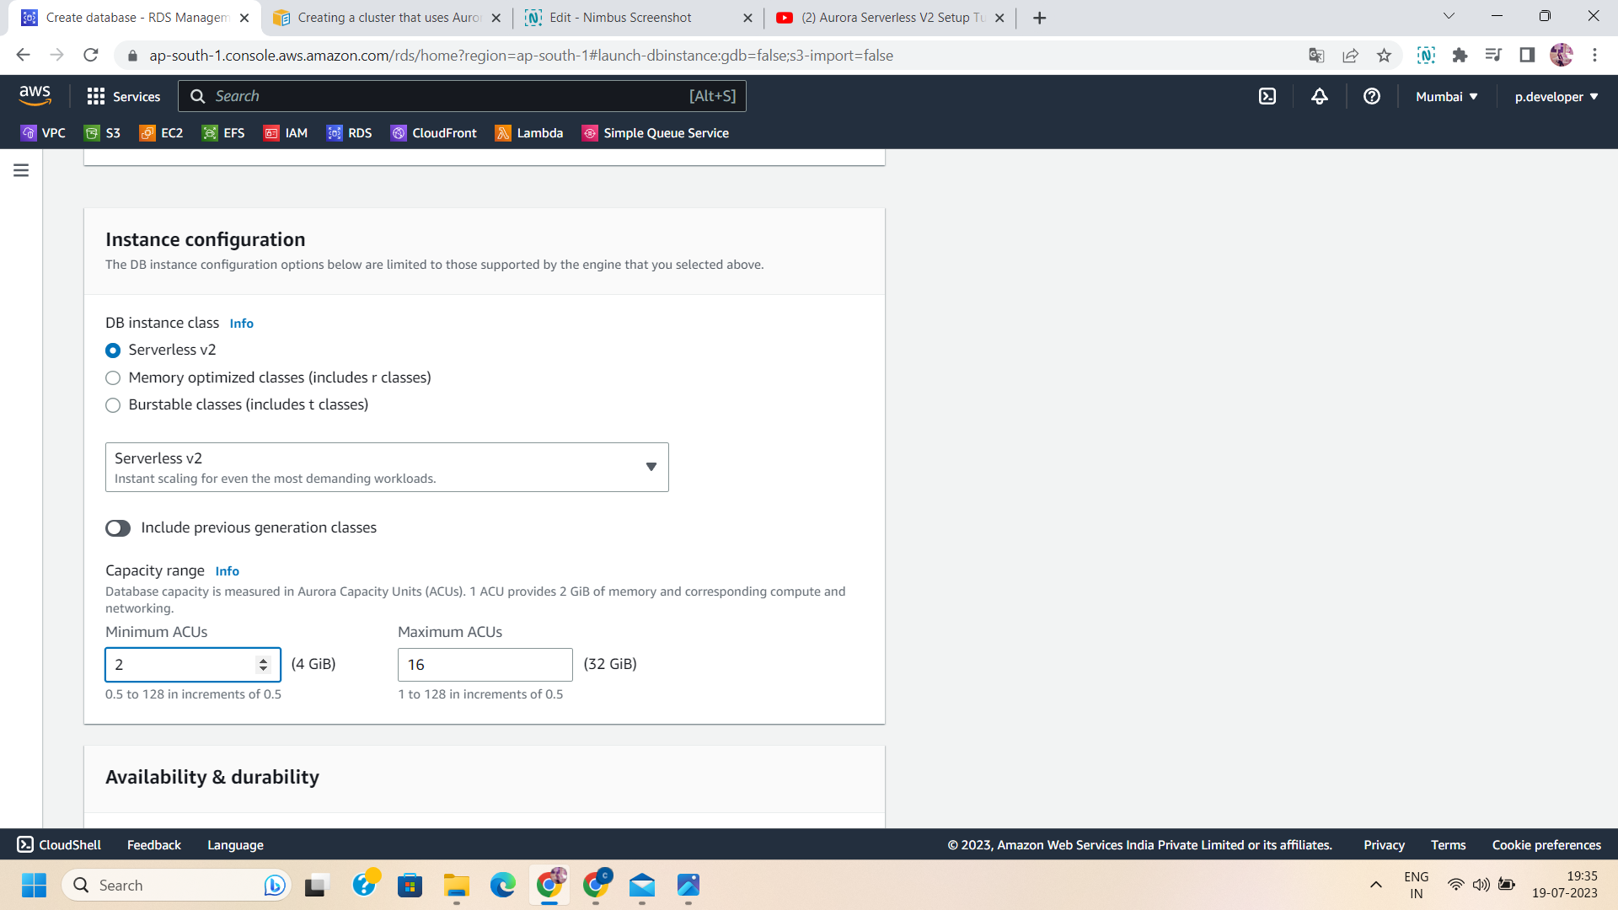

Step 9:Manage availability,durability and connectivity:

Enable the aurora replicas and configure the networking settings like connect ec2 instance to the database,specify VPC ,subnet,security groups and public level access.

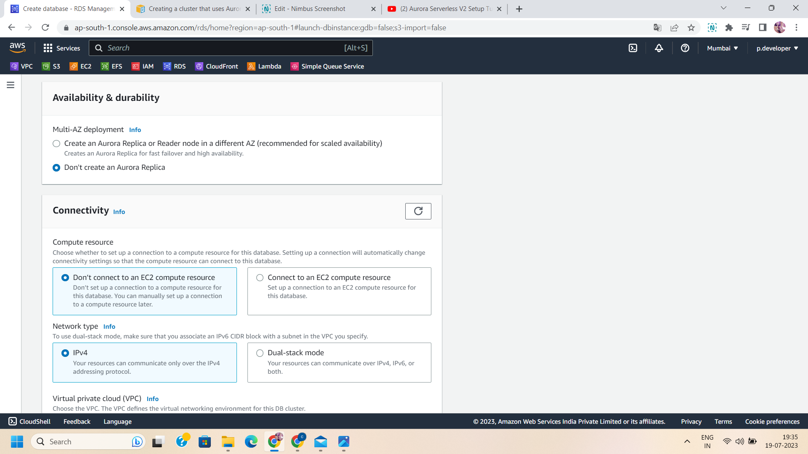

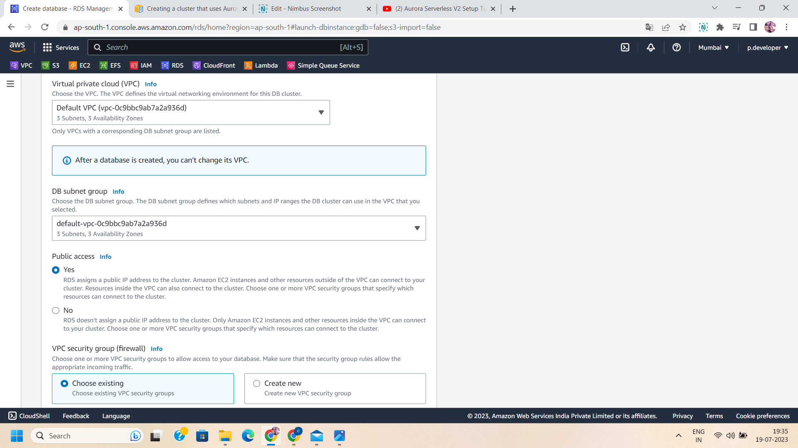

Step 10: Manage the database authentications:

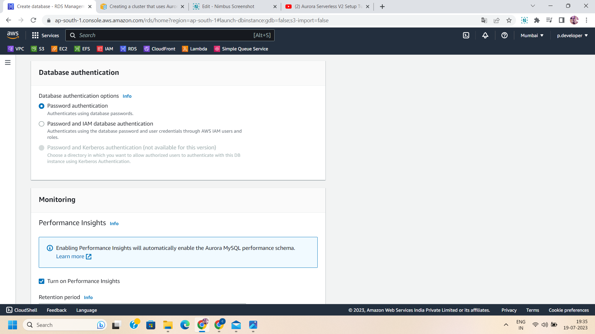

Step 11: configure the monitoring :

Manage retention period,AWS KMS key and performance insights.

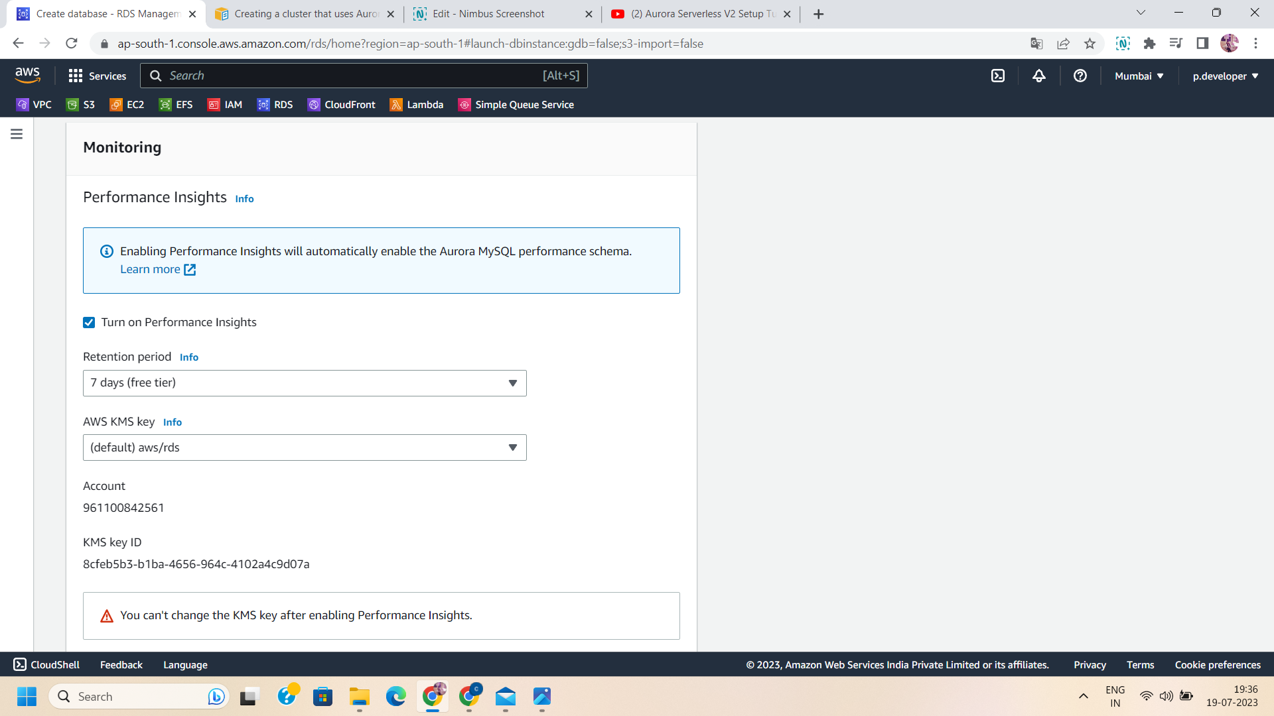

Step 12:Configure Additional settings:

Select the parameter groups,option group,backup,enable encryption,backtrack and log exports

And maintenance settings.

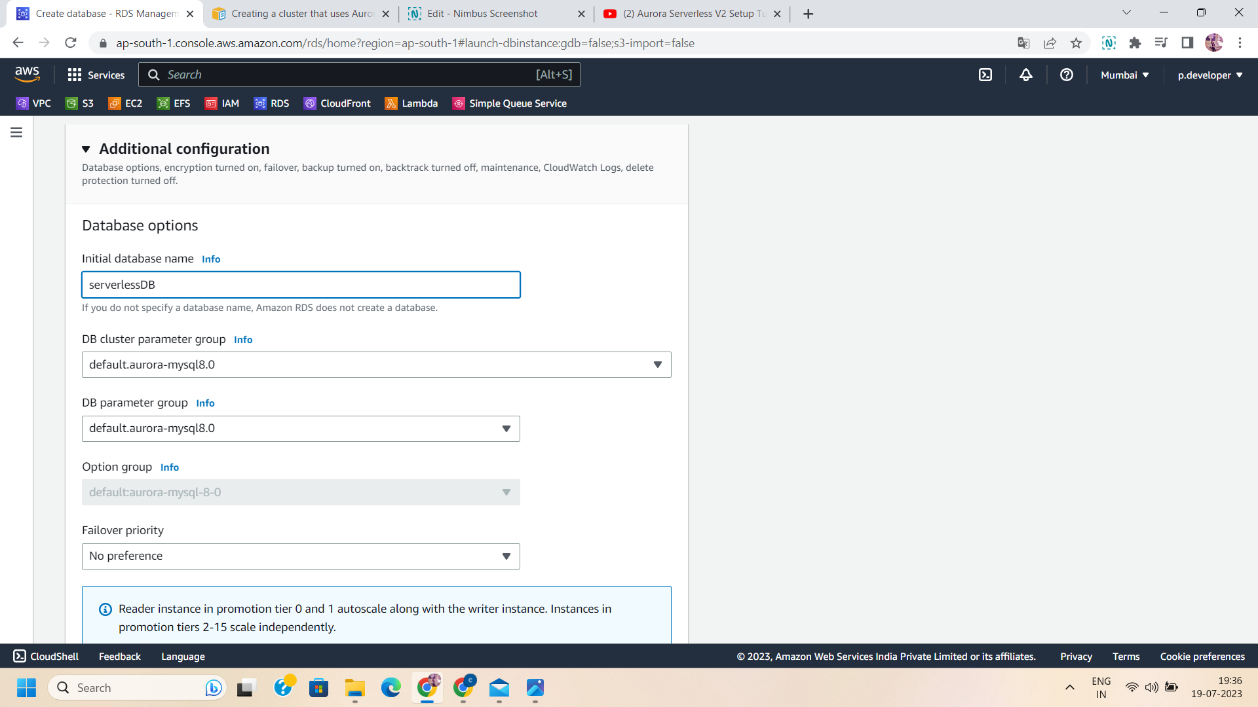

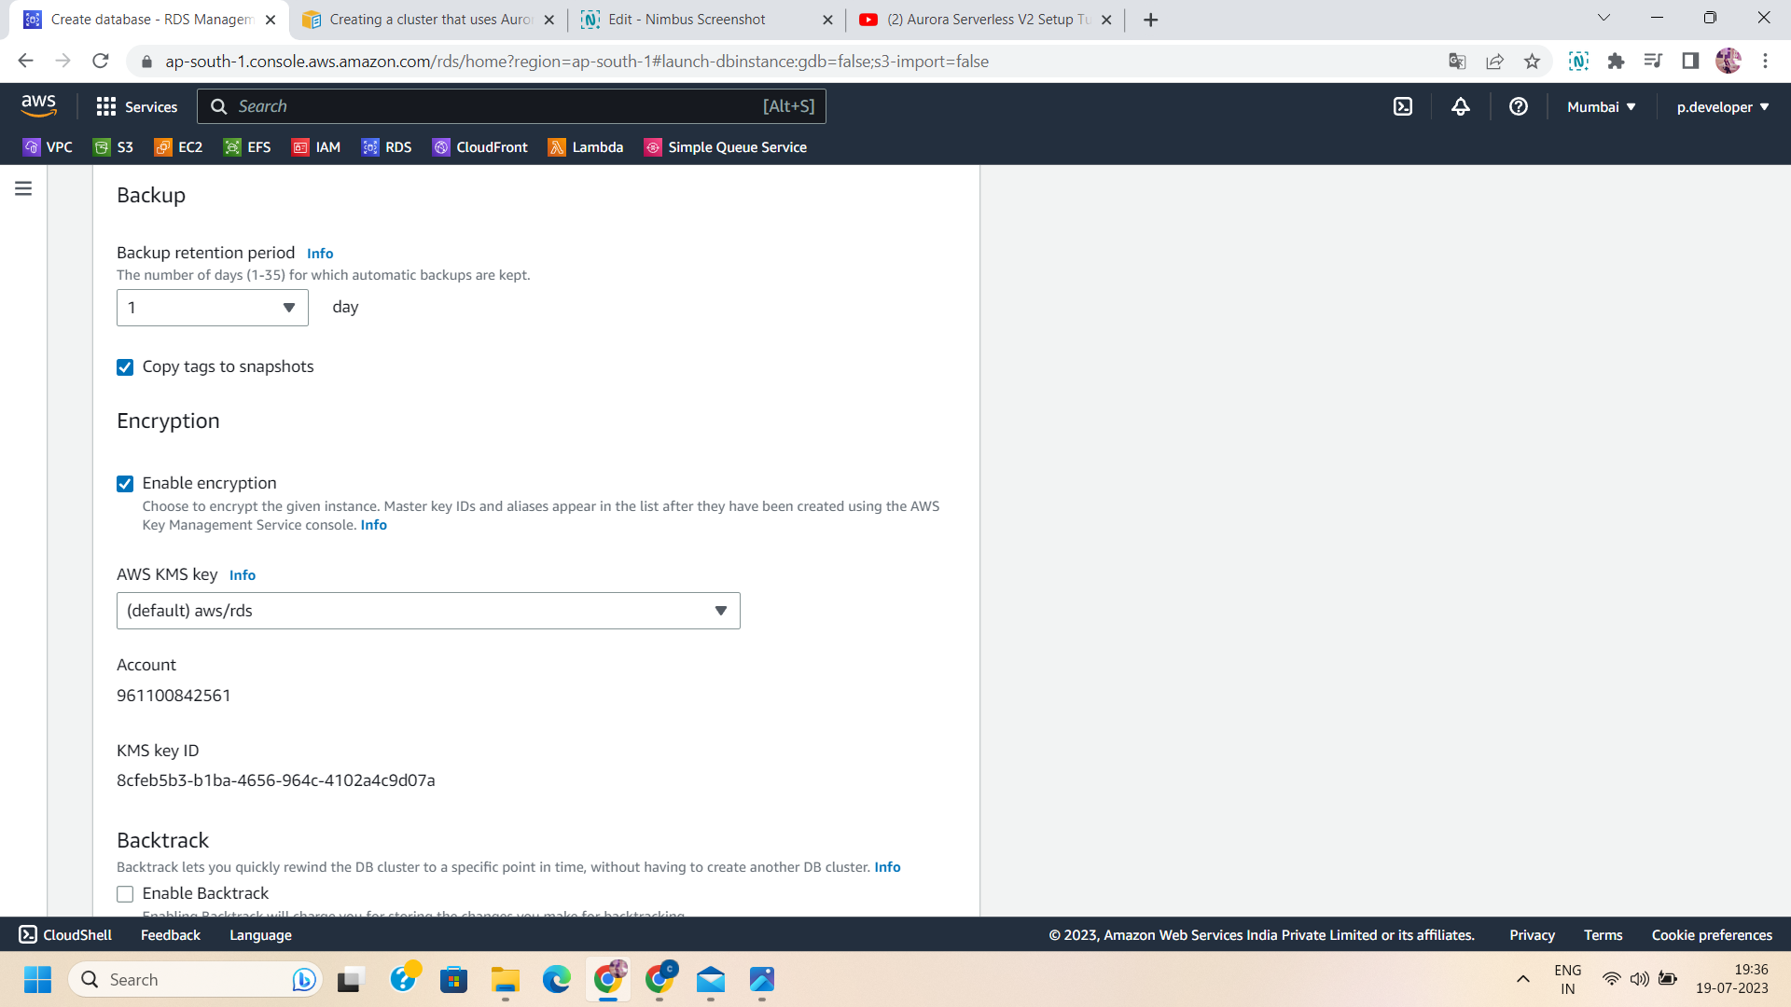

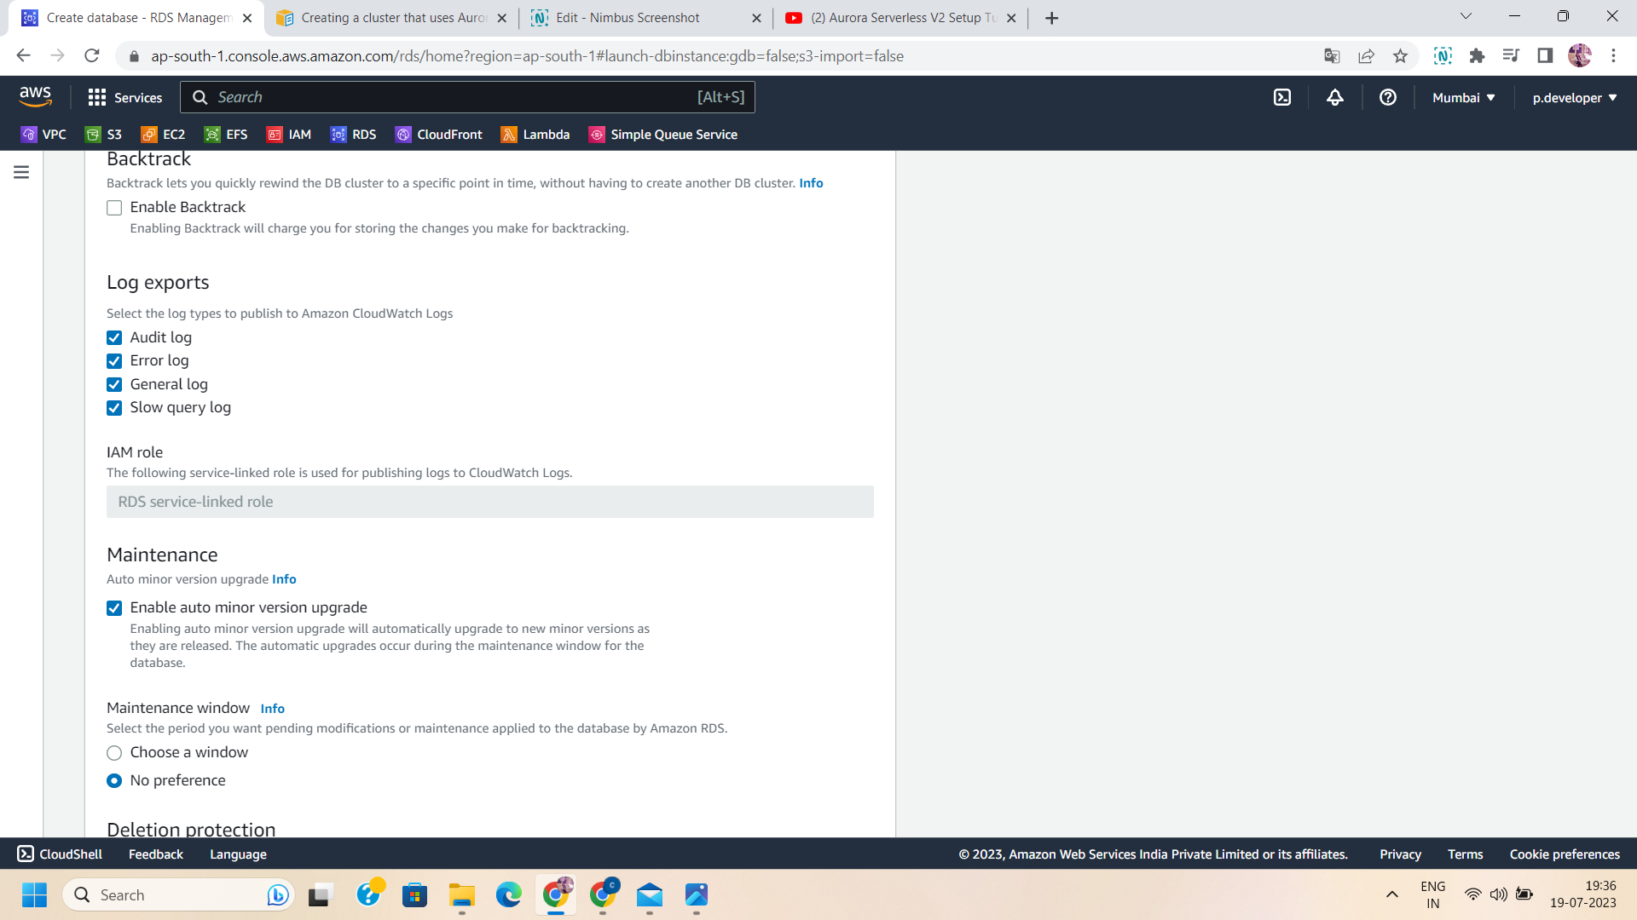

Step 13: After configuring all the settings,click on “create database” .

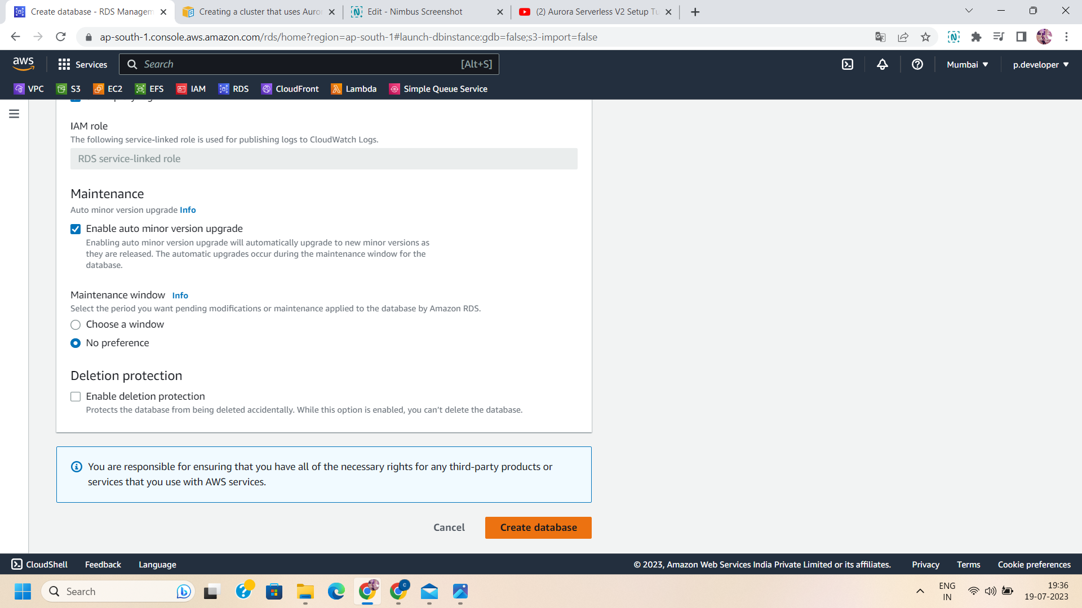

Step 14: Now,a serverless database is available and it is ready to utilize and implement queries.

